# **Persona 1: Cinephile Sam**



| **Name** | Sam Gamgee |
| --- | --- |
| **Demographics** | Age: 27  Gender: Male  Occupation: Grad student in Film Studies |
| **Life Circumstances** | Lives with roommates, tight budget, spends most free time watching films or writing reviews. |
| **Personal characteristics** | Passionate, curious, articulate, opinionated |
| **Goals** | Find a one-stop shop for his niche film tastes that will help him in his community of obscure media lovers. |

# **Persona 2: Curious Cassy**

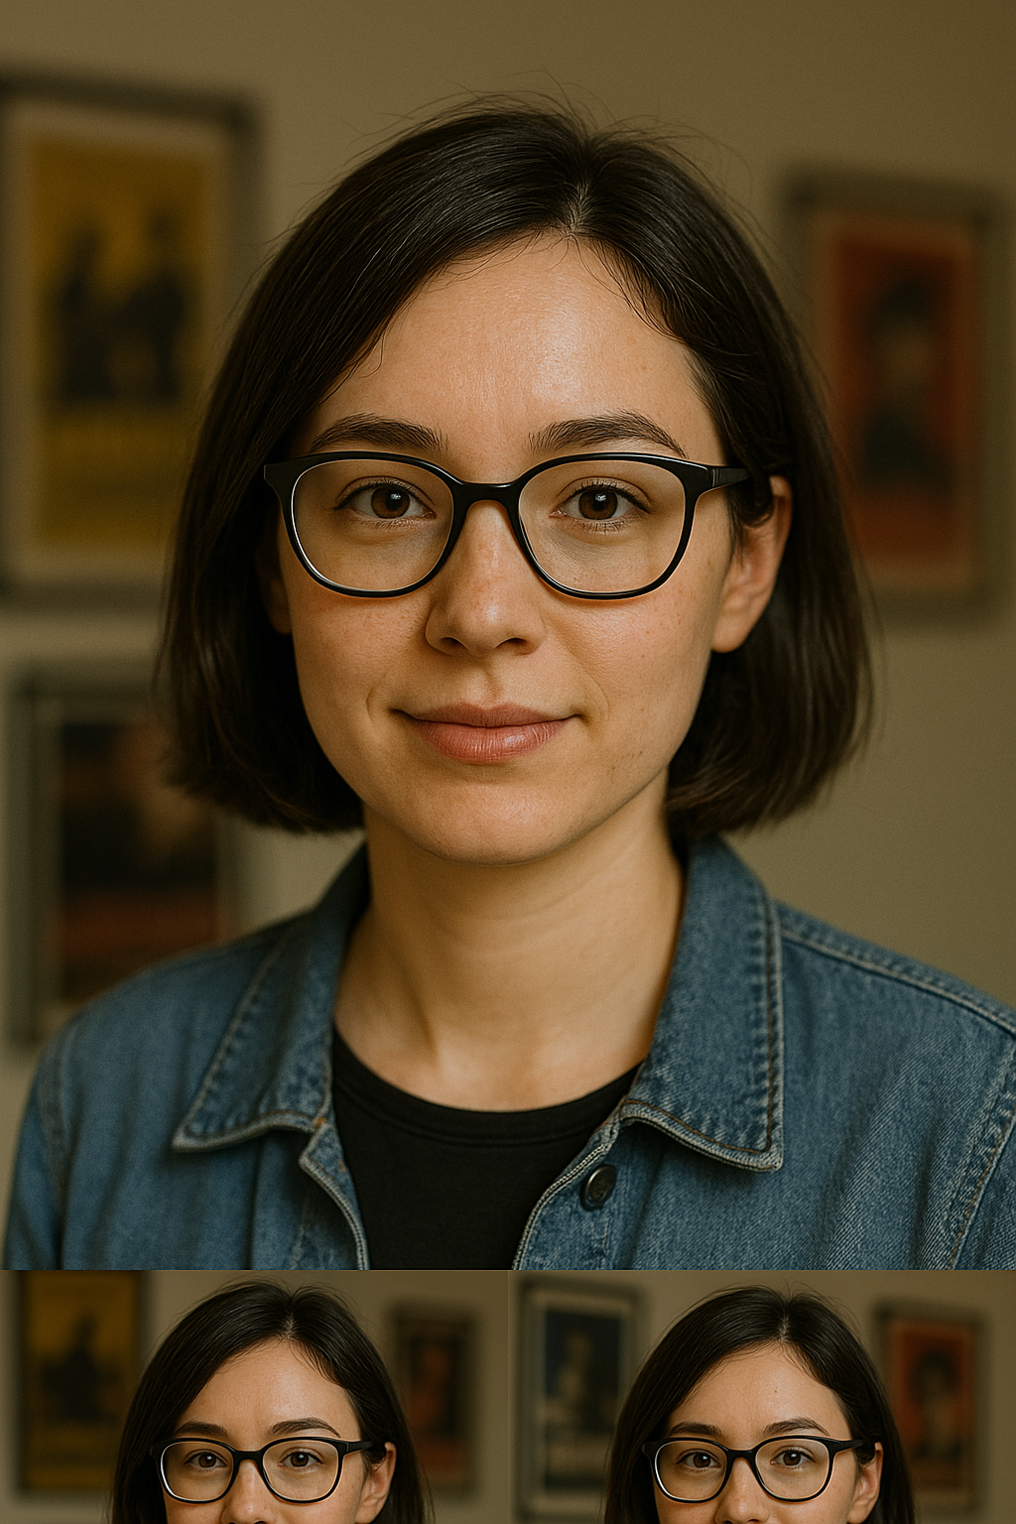

| **Name** | Cassy Yates |
| --- | --- |
| **Demographics** | Age: 28  Gender: Female  Occupation: UX Designer |
| **Life Circumstances** | Newly interested in art films after binging mainstream platforms |
| **Personal characteristics** | Inquisitive, open-minded, design-conscious |
| **Goals** | Get personalized recommendations to expand her knowledge and appreciation of niche films and media. |